Kent School
Health Service

Primary school partnership agreement

School name:
District:
Date:

Information at a glance | Page
School Health Service roles and responsibilities  - Context and background of the School Health Service  - The School Health Service  - Scope of the School Health Service | 3  3  4
Partnership agreement  - School Health Service responsibilities  - School responsibilities | 5  6
School Health Service model | 7
School specific sessions | 8
Partner services | 9
Contact details for School Health Service | 10
Appendix one – Letter re. DBS checks for KCHFT School Health Service staff visiting schools | 11

Context

KCHFT was commissioned from 1 April 2017 to provide primary and secondary School Health Services (five to 19 years) and Targeted Emotional Health and Wellbeing Services (EHWBS). The service includes children in mainstream school, special school, alternate curriculum units or home educated.

Three key themes strongly influenced the new service design:
- The School Health Service and the range of services offered needs to be more visible in schools and the community. This could be through activities that raise awareness of the range of services provided, as well as clarity regarding the role of the school (public health) nurse.

- Services need to be more accessible for children, young people, parents/guardians and schools. In particular, this applies to communication and improved dialogue.
- There needs to be a willingness to work together with stakeholders on further developing services in schools, from our school health staff and school staff, to parents, young people and primary care services. There is a real opportunity to co-create sustainable, innovative school
health services based on the needs of the local population.

The School Health Service

The School Health Service is a multi-skilled team with different practitioners. This includes:
- public health assistants,
- assistant practitioners,
- school staff nurses,
- specialist community public health nurses
- and a whole school approach team who focus on delivering a high quality, responsive, public health service to the whole school community.

The School Health Service is available 8am to 6pm five days a week, 52 weeks a year (excluding public holidays).

We also have a Children and Young People’s Counselling Service. For primary school-aged children, we can offer the child six face-to-face sessions with a counsellor, in a clinic setting or if more appropriate, we can offer parents six virtual weekly sessions with advice on practical, easy to use strategies to support your child.

Our dedicated team of administrators handle all referrals and telephone calls into the service. This team is known as our Central Administration Team (CAT). The referrals are triaged by qualified clinicians who assess the level of need and assign to a practitioner for intervention or support
as required.

family.kentcht.nhs.uk/

Referrals can be made directly by parents or carers, young people themselves or by partner agencies, using the online referral form which can be accessed via the link below:

www.kentcht.nhs.uk/forms/school-health-service-referral-form/

Contact number: 0300 123 5205

.

Scope of the School Health Service

Our teams work hard to improve the general health and wellbeing of children, young people and their families to support children to get the best start in life.

The school health teams are led by qualified school nurses, with specialist training in public health. They are supported by school staff nurses, assistant practitioners, public health assistants and an administration team. We also have a whole school approach team working in partnership to promote health and wellbeing at a whole a school level. In addition, we have a dedicated team of counsellors working within the service to support children and young people.

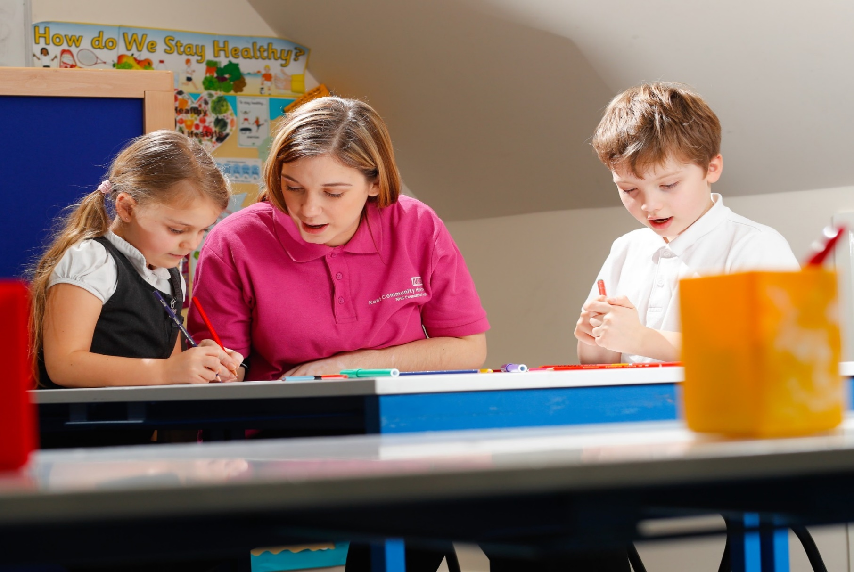
As a public sector organisation delivering a contract commissioned by NHS England we provide assurance under contract to NHSE that our colleagues are appropriately trained, qualified and checked (DBS). It is not appropriate for our staff to carry or present their certificates to a third party.

Secure emails: School health colleagues use NHS.net email addresses which means emails are encrypted when sent. However, for the information to remain secure, it needs to be sent to a secure email address. NHS.net have offered a solution to enable those without secure emails (such as schools and parents) to securely receive confidential information. To read emails, schools will need to create an Egress account which is free to use. For further information on Egress visit family.kentcht.nhs.uk/wp-content/uploads/sites/10/2023/06/Accessing-encrypted-emails-guide.pdf

This partnership agreement will make sure that children and young people in schools receive the best possible outcomes as outlined in the five to 19 Healthy Child Programme (Department of Health, 2009).

The School Health Service is responsible for the following:

- Share data (individual and community level) to support planning and service delivery in accordance with GDPR, for example school health profiles.

- The School Health Service will make sure all staff have up-to-date enhanced DBS clearance. All Kent Community Health NHS Foundation Trust staff have enhanced child and adult DBS clearance. All staff are issued with a photo ID badge which will be worn at all times (see appendix one).

- Liaise with an identified member of school staff to plan and agree dates for National Childhood Measurement Programme in reception and year six. This takes place from September to July each year.

- Liaise with an identified member of school staff to plan and agree dates for vision and hearing screening in reception. This takes place from September to July each year.

- Liaise with an identified member of school staff to plan the roll out of the health needs assessment questionnaires where appropriate for reception and year six pupils using The Lancaster Model www.thelancastermodel.co.uk/

- Working within professional and ethical guidelines and be accountable for their practice, in accordance with KCHFT policies Kent Community Health NHS Foundation Trust and NMC guidance.

- Be visible, through regular visits from school health team (as agreed at the beginning of the school year).

- Be accessible through improved communication via face-to-face, online presence and a centralised contact system.

- Coordinate with a named member of school staff to plan all School Health Service activities, including visits as required during the school term

- Provide end of year activity reports to schools and highlight relevant information (where school has taken part in The Lancaster Model)

- Support the school to deliver health promotion sessions based on needs of the school using the School Health profile (as agreed at the beginning of the academic year).

- The School Health Service will support schools to engage with the Kent resilience toolkit, promoting resilience across the whole school community and supporting staff to feel confident in having resilience-based conversations.

- The School Health Service has a statutory responsibility to be involved with any child or young person, who is subject to a safeguarding plan, where a referral has been received into the service for an unmet health need. We will work in partnership with the school/referring agency to meet the needs of the child/young person and will share information appropriately.

Additional activities by prior agreement:
- Deliver health needs awareness sessions to school staff on asthma, anaphylaxis and epilepsy (these sessions are offered online). We also offer a continence webinar to raise awareness of steps schools can take to support children experiencing difficulties with day or night time wetting.

- Attend parent’s evenings and school assemblies when appropriate, agreed in advance. It is the responsibility of the school to request SHS attendance at any event and we would recommend giving at least a term’s notice.
The school is responsible for the following:

- Identify a named member of staff who will liaise with the School Health Service.

- Share data at an individual and community level to support planning and service delivery in accordance with GDPR.

- Actively promote the completion of the health needs assessment questionnaires in reception (by parents) and year six (by pupils) and work in partnership with the School Health Service named lead to help increase the uptake of this programme.

- Provide a confidential space for one-to-one consultation taking place at school, which is a safe environment for lone working purposes and accessible for students.

- Provide an appropriate space in order to see children for school entry screening (vision and hearing) for reception and the National Childhood Measurement Programme (NCMP) in reception and year six (room requirements are clearly set out in pre-measurement/screening letters to schools)

- A person of appropriate seniority should be present at all individual health care planning meetings and is responsible for sharing information with other senior staff as appropriate

- Send appropriate staff to health needs training as advised by named school nurse.

- Provision of IT equipment to be set up and ready to use for any training sessions/ events and to complete TLM.

- Request for a School Health Service representative to attend new parents evening/transition events to be negotiated at least half a term in advance. If this level of notice is not given, we cannot guarantee that we will be able to provide a member of staff to attend.

- Each school will register on the Kent resilience hub website. Schools will engage with the Kent resilience toolkit and promote a culture of resilience within their school community.

- Where a child has an identified school health need and there is a safeguarding concern specifically relating to the unmet school health need, the school will share relevant information with the School Health Service.

School Health Service model
The School Health Service model has three levels of provision; universal reach, personalised response and specialist support with safeguarding children and young people as a key component running throughout the model. The model is built on the principles of proportionate universalism, providing a service that is universally accessible to all, however, offers additional help for those who need it most. The model represents a continuum of need for most children and young people

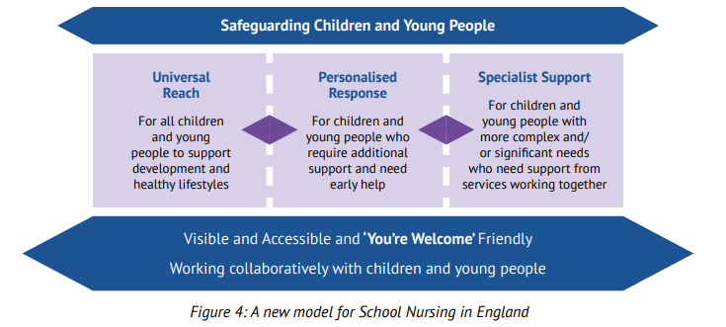

Visit www.gov.uk/government/publications/commissioning-of-public-health-services-for-children/health-visiting-and-school-nursing-service-delivery-model to find out more information on the details of a modernised health visiting and school nursing service delivery model that is ‘Universal in reach – personalised in response’.

The NHS Long Term Plan sets out the priorities for expanding children and young people’s mental health services. To deliver these priorities, Kent and Medway has a local transformation plan in place. For more information visit the Local Transformation Plan 2022 for children, young people, and young adults’ emotional wellbeing and mental health - www.kmhealthandcare.uk/transformation-projects/children-young-people-and-young-adults-emotional-wellbeing-and-mental-health

School specific sessions

- The National Childhood Measurement Programme will be offered to weigh and measure children in reception and year six. This is a parental opt out and parents can either telephone or email the School Health Team.

- Hearing and vision screening in reception is a parental opt out. Parents can either telephone or email the School Health Team.

- Targeted interventions can be completed for a range of health needs including emotional wellbeing, and referral on to specialist services where necessary.

- Packages of care (e.g. behaviour management, daytime and night time wetting and soiling, emotional health and wellbeing, healthy weight) are offered where identified to be appropriate through assessment.

- The School Health Service can support the development and review of Health Care Plans for children who are open to our service with long- or short-term conditions and Education, Health and Care (EHC) plans as required.

- Assessments will be offered at reception and year six using The Lancaster Model which is an early identification and
preventative model to assess strengths, needs and risks. The purpose of The Lancaster Model (TLM) is to provide the opportunity to discuss concerns and aspirations; assess physical health, growth and development; assess any mental or emotional issues; and identify any needs which require progressive (targeted) interventions.

The questionnaires have been formulated to provide early intervention alerts by using research, government targets and public health priorities to enable the identification of individual pupils who may require a targeted intervention, support or information. For more information please visit: www.thelancastermodel.co.uk

- General health awareness sessions are available on-line to support school staff to manage children/ young people with long term health needs such as anaphylaxis, epilepsy and asthma.

- The School Health Service can offer attendance at transition events for parents of new entrant reception children to highlight key public health issues for the child and their families.

Partner services

NELFT - North East London Foundation Trust (NELFT) provides integrated Children and Young People’s Emotional Health and Mental Health Services (CYPMHS).
www.nelft.nhs.uk/services-kent-children-young-peoples-mental-health

The School-aged Immunisation Service (SAIS) offers the Childhood Flu vaccination (nasal spray) to all primary school-aged children.

Contact details for the School-aged Immunisation Team are as follows:
Telephone: 0300 123 5205
Email: kchft.cyp-immunisationteam@nhs.net
Website: family.kentcht.nhs.uk/imms

If a child has missed their immunisation in school, is home educated or needs to catch up with their immunisations for any reason, parents can bring them to one of the community clinics.

Contact details

School Health Team
Phone: 0300 123 5205

Email: kentchft.kentschoolhealth@nhs.net

Whole School Approach

Email: kentchft.wholeschoolhealth@nhs.net

Kent School Health website: family.kentcht.nhs.uk/

Kent Youth Health website: www.kentyouthhealth.nhs.uk/

Amber Bond | Head of Service, Kent School Health | amberbond@nhs.net | 07891 194509
Allison Leigh | Clinical Lead for School Nursing | allison.leigh@nhs.net | 07557 663368
Jane Edwards | Clinical Lead for Emotional Health and Counselling | jedwards21@nhs.net | 07824 608271
Michele Ellis | Screening Lead for School Nursing | m.ellis2@nhs.net | 07391 860956
Jean Ravenna | Transformation Manager | jeanravenna@nhs.net | 07795 256891
Zoe Fish | Whole School Health Lead | Zoe.fish@nhs.net | 07825 230949
Christine Beer | School Nurse Education Lead | chrisbeer@nhs.net | 07946 171122
Helen Sharman | District Manager – East Kent | helensharman@nhs.net | 07391 861425
Gemma McCairn | District Manager – South Kent | g.mccairn@nhs.net | 07392 863921
Beth Epps | District Manager – North Kent | bethepps@nhs.net | 07557 139388
Rachel Hawkett | District Manager – West Kent | rachel.hawkett@nhs.net | 07751 731623

Appendix 1

Template DBS letter

Public Health and Prevention Directorate
Trinity House 110-120 Upper Pemberton
Eureka Park
Ashford
Kent TN23 7SH
Web: www.kentcht.nhs.uk

Dear Head Teacher,

Disclosure & Barring Service Checks for Kent Community Health NHS Foundation Trust Staff visiting schools and other educational settings

Kent Community Health NHS Foundation Trust (KCHFT) places a high value on our partnership with schools and colleges. We hope that the clarification with regard to KCHFT staff member’s DBS certification will provide confidence in the systems that we have in place, to ensure safety, compliance with statutory obligations and promote wellbeing.

KCHFT position statement with regard to its staff member’s DBS certification

The Trust remains responsible for all of its staff members whilst undertaking any supervised regulated activity in schools, colleges or other educational settings. KCHFT remains the ‘employer’ (or in DBS terms the personnel provider) with responsibility for the management of the DBS process.

The Trust has a formal DBS checking procedure in place which includes obtaining a DBS Enhanced Disclosure with Child Barred List (List 99) check. This includes all identity checks in line with the DBS Code of Practice.

This letter serves to confirm that a core criminal record check, including a check of the children’s barred list, has been completed and that all individuals working with yourselves on behalf of the Trust have been judged to be suitable to work with children. This, in combination with our recruitment process and occupational health screening, ensures the Trust complies with all requirements of the Keeping children safe in education (Department for Education, 2023): Statutory guidance for schools and colleges.

KCHFT does not support any additional scrutiny of the DBS certificates by a receiving organisation, as this would undermine the confidentiality of the systems already put in place by KCHFT.

KCHFT actions to ensure compliance in line with the National Legislation and Guidance

- Any DBS Enhanced Disclosure which has anything recorded is scrutinised by qualified persons within the Trust. These persons have the obligation to ensure that all staff employed by the Trust fully meet the DBS requirements for the position they hold. As for all staff members, who’s role requires them to have unsupervised regular access to children and young people, the Trust confirms that an Enhanced DBS check has been completed, references have been obtained, the employee has received medical clearance and is eligible to work in the United Kingdom of Great Britain.

- Any staff member who has a career break for a term or longer is required to complete a new DBS Enhanced Disclosure certificate and a Childcare Disqualification declaration before they are able to undertake any activity that would entail unsupervised access to children and young people.

- The Trust maintains comprehensive records of all its staff members. These include the DBS certificate numbers and issue dates. This information is available for disclosure to the appropriate authorities, in accordance with the law.

- A KCHFT staff member is not obliged to show or make a copy of their DBS certificate as this would compromise the confidentiality of the system. All KCHFT staff members are issued with an ID card containing a photograph and this will assist organisations with internal verification procedures.

- The Department for Education has published statutory guidance on the application to schools of the Childcare (Disqualification) Regulations 2009 and related obligations under the Childcare Act 2006. KCHFT has due regard to this statutory guidance when carrying out its duties to safeguard and promote the welfare of children. KCHFT confirms that we act in accordance with these regulations.

Yours sincerely

Ali Carruth
Executive Director Health Inequalities and Prevention

Page 2 of 2

Version:
Date of publication: November 2023

